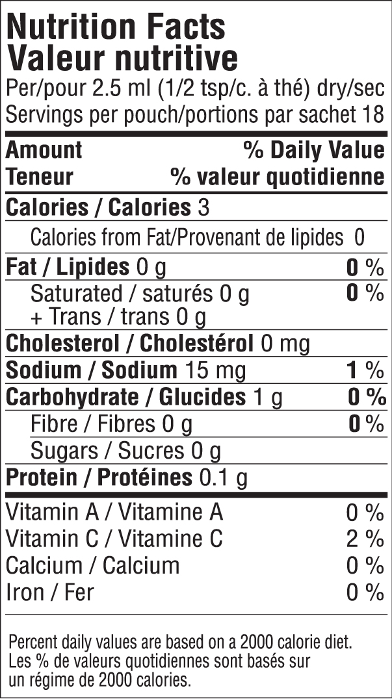

INGREDIENTS:

ONIONS, GARLIC, HERBS & SPICES, SEA SALT, GREEN BELL PEPPER, GREEN ONION, NATURAL FLAVOUR.

