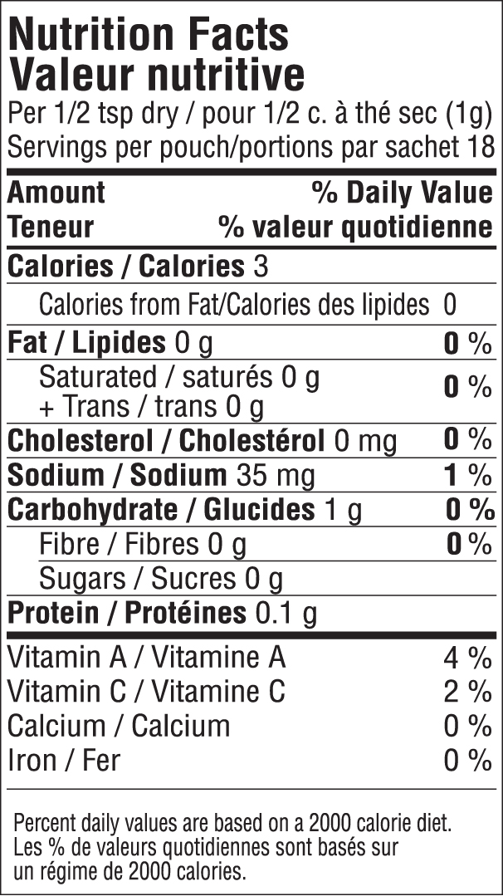

INGREDIENTS: ONION, SPICES, SALT, MANGO POWDER, GREEN ONION, RED BELL PEPPER, MUSTARD, GARLIC. CONTAINS MUSTARD

