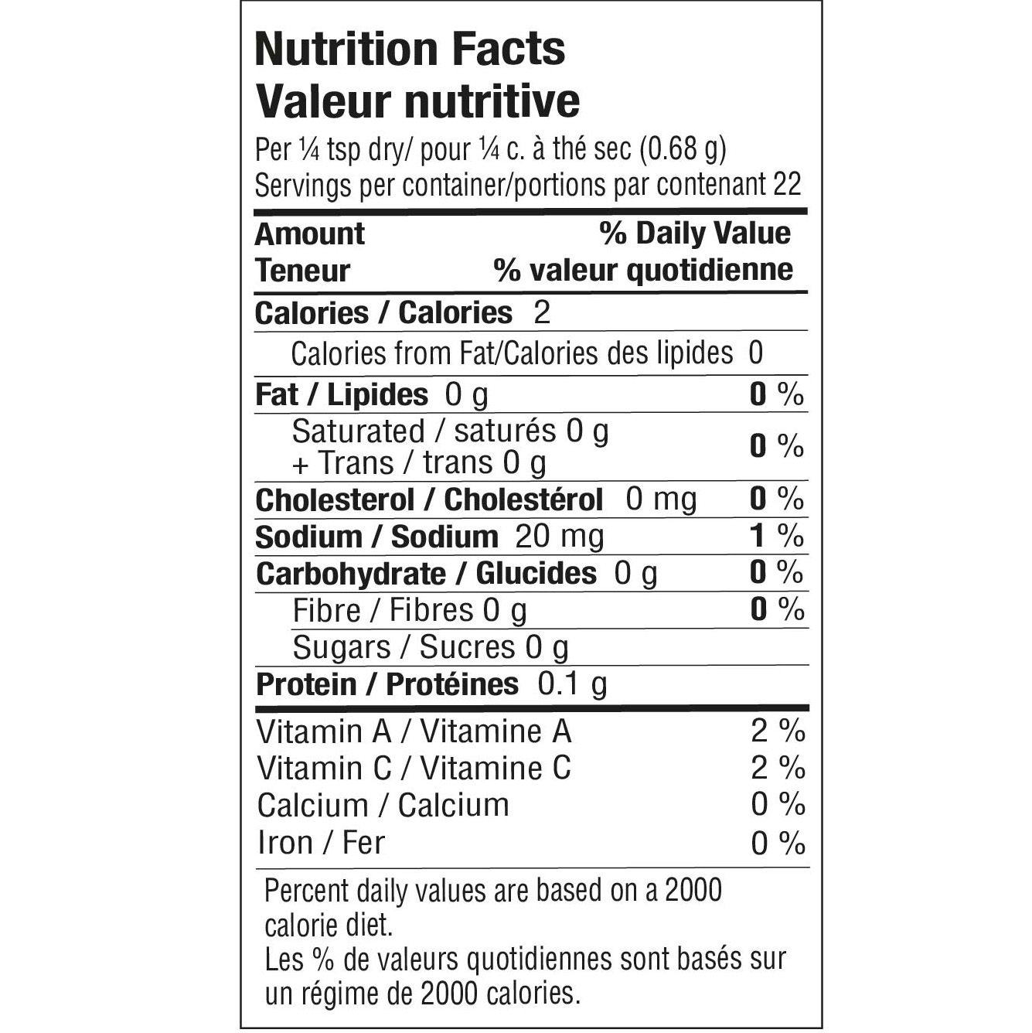

INGREDIENTS: ONION, GARLIC, SPICES, LEEK, SEA SALT, GREEN ONION, MUSTARD, CORN STARCH, RED BELL PEPPER, CHEESE FLAVOUR (MALTODEXTRIN, WHEY SOLIDS (MILK), NATURAL PARMESAN CHEESE FLAVOUR, SALT), LEMON PEEL, CITRIC ACID. CONTAINS: MILK AND MUSTARD

