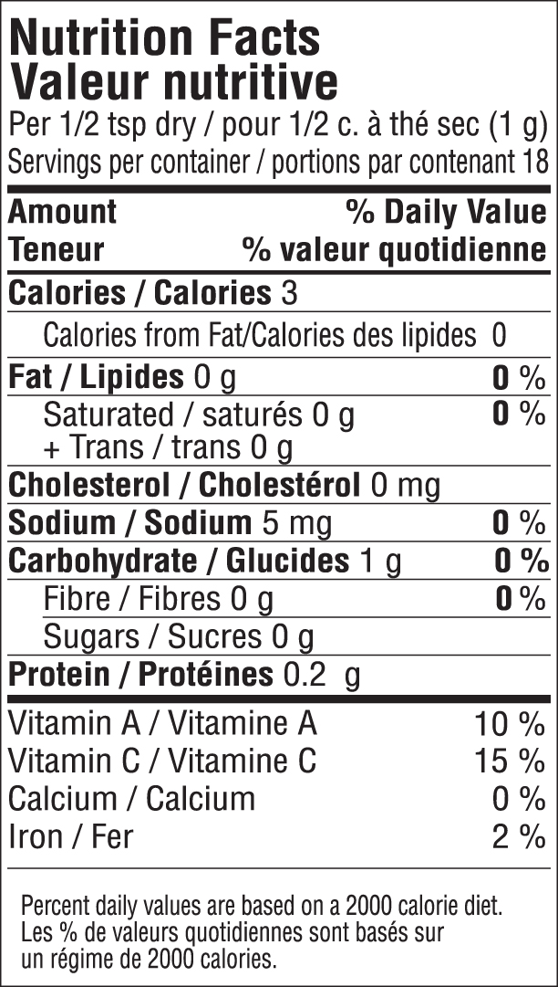

INGREDIENTS: DEHYDRATED VEGETABLES (RED BELL PEPPER, ONION, CHIVE, GARLIC), SPICES (PAPRIKA), DEXTROSE, SEA SALT.

