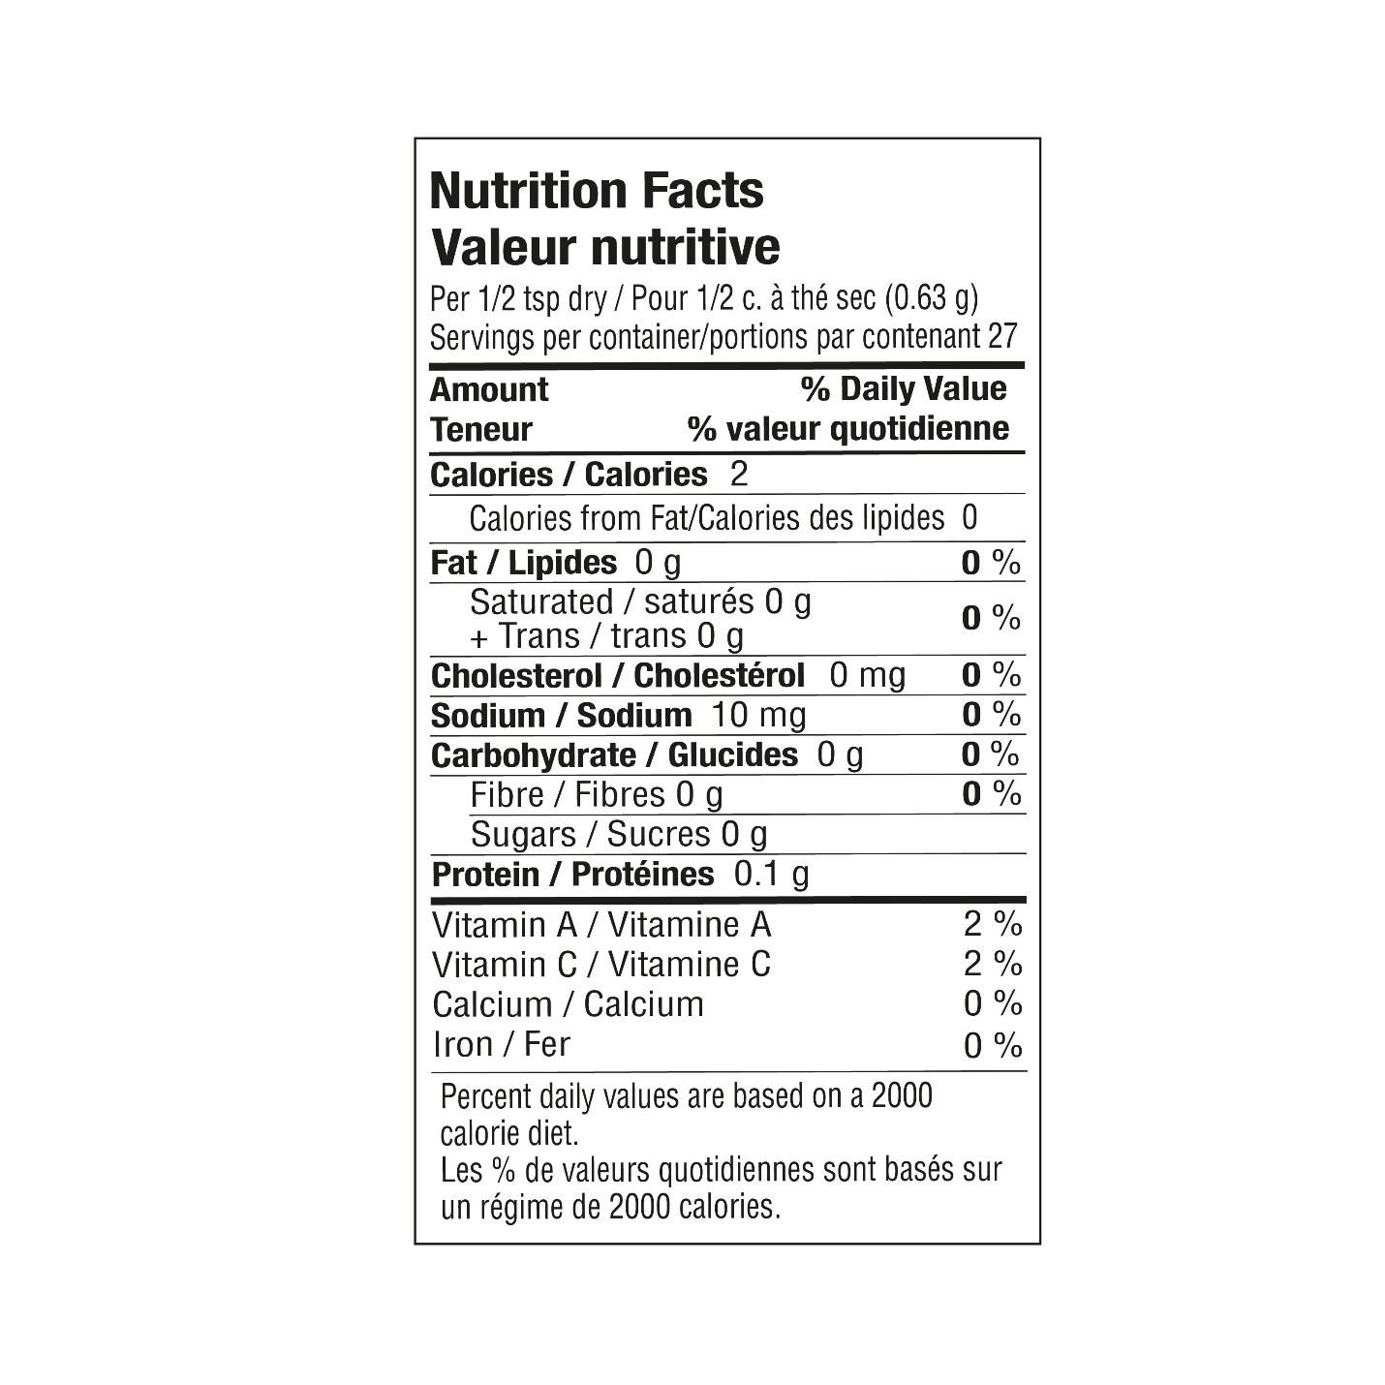

INGREDIENTS: ONION, GARLIC, SPICES, LEEK, GREEN ONION, SEA SALT, **MUSTARD**, SPINACH, RED BELL PEPPER, LEMON PEEL, CITRIC ACID. **CONTAINS MUSTARD**. LOW SODIUM