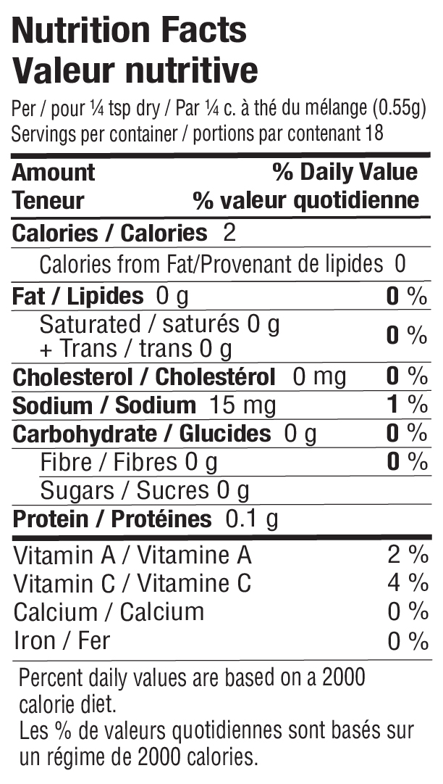

INGREDIENTS: SPICES, DEHYDRATED VEGETABLES (GARLIC, ONION, GREEN ONION, JALAPENO), LEMON
PEEL, SEA SALT, CITRIC ACID, SUGAR, CORN STARCH, NATURAL LIME FLAVOUR.

