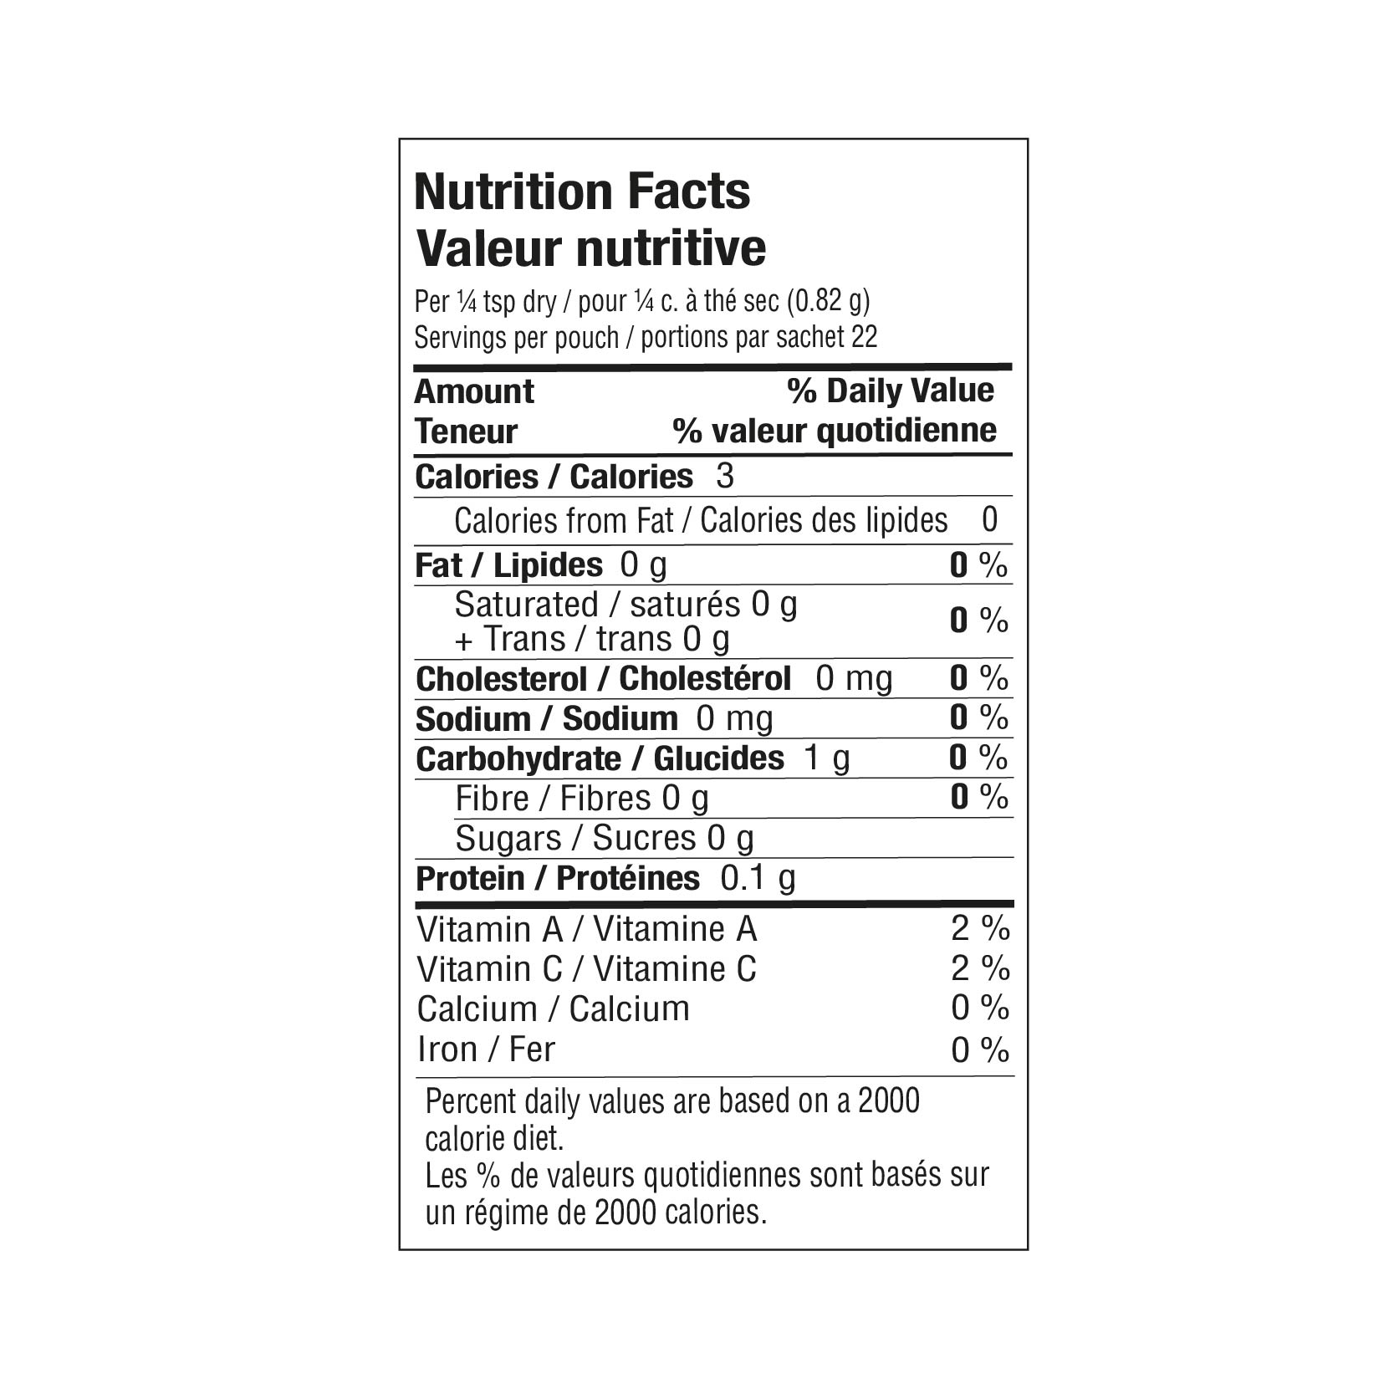

INGREDIENTS: ONION, GARLIC, GREEN ONION, LEEK, SPICES.

